MEDIA RELEASE
For immediate release November 2015
Blockbuster depreciation claims for winning bidders on The Block
Analysis from Australia’s leading supplier of tax depreciation schedules suggests that investors could claim an average of over $1.5 million in depreciation deductions for each apartment on Channel 9’s The Block: Blocktagon.
According to estimates provided by BMT Tax Depreciation, Dean and Shay’s penthouse apartment has the highest amount of depreciation deductions available, with a minimum of $62,735 that could be claimed in the first year and $1,621,688 over the specified lifetime of the property.
Luke and Ebony’s apartment 5/1A Affleck Street South Yarra has the second highest amount of total minimum depreciation deductions available at $1,600,297.
“As the property with the highest amount of total depreciation deductions available, Dean and Shay’s apartment may prove attractive to sophisticated investors,” said Bradley Beer, CEO of BMT Tax Depreciation.
“While there are many factors that will decide which apartment achieves the highest price, the additional cash flow astute property investors receive from depreciation will assist them when crunching their numbers to make purchase decisions.
“While Dean and Shay look to be the clear winners in terms of unlocked depreciation value - it’s a very close field,” said Brad Beer.

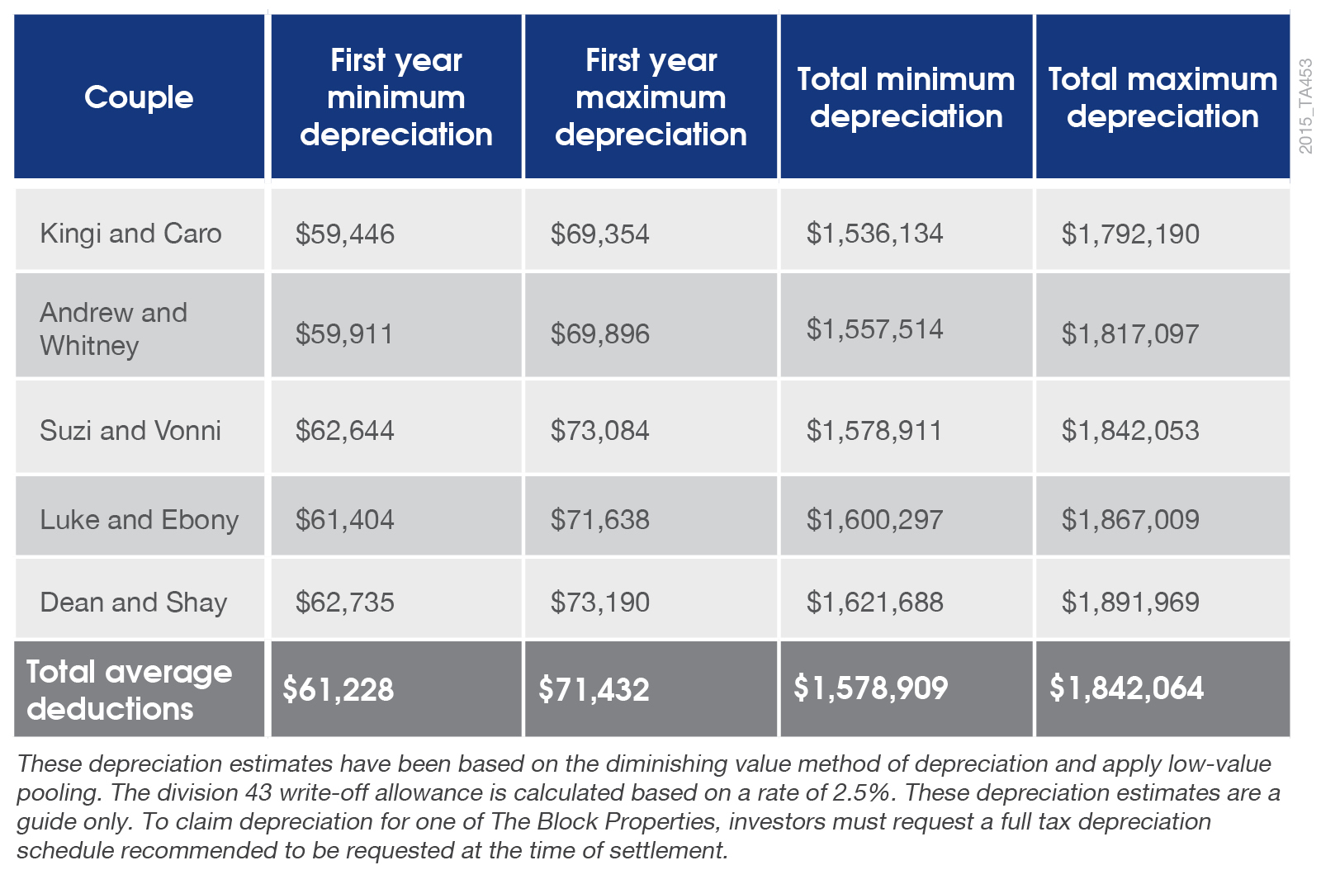
Below is a summary of the depreciation estimates BMT Tax Depreciation found for all five apartments after conducting a site inspection and providing their analysis of the potential deductions investors can claim once the properties are income producing.

The South Yarra property, originally a 34 room hotel, was reportedly purchased by The Block’s production company for $6.25 million in 2014. The building has undergone an extensive renovation on the show and when finished will be home to five luxury apartments.
Bradley Beer will appear on the show on the 17th of November 2015 to share his expert knowledge with the contestants regarding depreciation deductions for their properties.
Quantity Surveyors are one of the few professionals recognised by the Australian Taxation Office as having the appropriate construction costing skills required to estimate building costs for depreciation.
Legislation allows the owners of any income producing property to claim depreciation deductions for the wear and tear of the building structure and the assets contained within.
“Despite the huge windfalls available to investors through depreciation deductions, research suggests that 80 per cent of property investors fail to take full advantage of property depreciation,” said Bradley Beer.
“Any property investor who doesn’t claim the maximum depreciation deductions available could be missing out on thousands of dollars in tax savings,” concluded Bradley Beer.
The apartments on The Block: Blocktagon will go to auction this weekend on Saturday 21 November.
*ENDS*
Media contact: Brad Beer, 0413 271 777, brad.beer@bmtnews.com.au
About BMT Tax Depreciation
BMT Tax Depreciation (BMT) is a Quantity Surveying company specialising in the provision of tax depreciation schedules for residential and commercial investment properties. Commencing business in 1997, demand from property investors nationally has seen business expand Australia-wide with offices now located in Sydney, Parramatta, Melbourne, Brisbane, Newcastle, Adelaide, Perth, Gold Coast, Cairns, Canberra, Hobart and Darwin.

